📑 Technical Architecture: Agentic Dashboard Generator (MVP v1.0)
1. System Overview 🧠
An AI-architected system that generates Dash/Plotly dashboards by interpreting business requirements (BRDs) and mapping them to existing codebase templates.
2. Data Strategy & Security 🛡️
Component | Specification
Input Sources | Hybrid: Flat Files (Excel/CSV) + Enterprise APIs (REST) 🖇️
Refresh Strategy | On-Demand/Triggered 🖱️ (User-initiated sync)
PII & Compliance | Automated Redaction 🛡️ (Masking sensitive data before processing)
Authentication | User-Session Injection 🔑 (Session-based keys; no server-side storage)
Localization | Dual Language Support 🌐 (English + one primary language)
3. The "Agentic Brain" & ETL 🐍
- Context Memory: Managed Vector DB (Pinecone/Weaviate) 🧠 for persistent project metadata.
- Logic Mapping: Uses Proactive Calculation and Semantic Search to bridge gaps between requirements and raw data 🧮.
- ETL Execution: Code-First approach using Polars/Pandas for high-performance transformations 🚀.
- Currency Handling: Stores original values with a Global Toggle for base-currency reporting 💶.
4. Visualization & UI Framework 🎨
- Visual Strategy: Comparative Analysis of historical reports + Framework Constraint checks ✅.
- Fallback Logic: Prioritizes Visual Similarity (e.g., Gauge ➔ Donut) if a component is unsupported 🔄.
- Organizational View: Unified Global View with entity-level filters 🌍.
- Code Structure: Template-Driven 🧩 (Filling slots in your existing framework).
5. Validation & Success 🧪
- Primary Success Metric: Automated Unit Tests 🧪 (Pass/Fail reports for data types and calculations).
- Data Health: Detailed Validation Report 📄 listing all assumptions and errors.
- User Onboarding: Business Logic Tooltips ℹ️ explaining what each metric represents.
- Error Handling: Visual Alert System 🚨 (Warning icons and cached data fallback for broken sources).

System Data Flow Diagram 📊
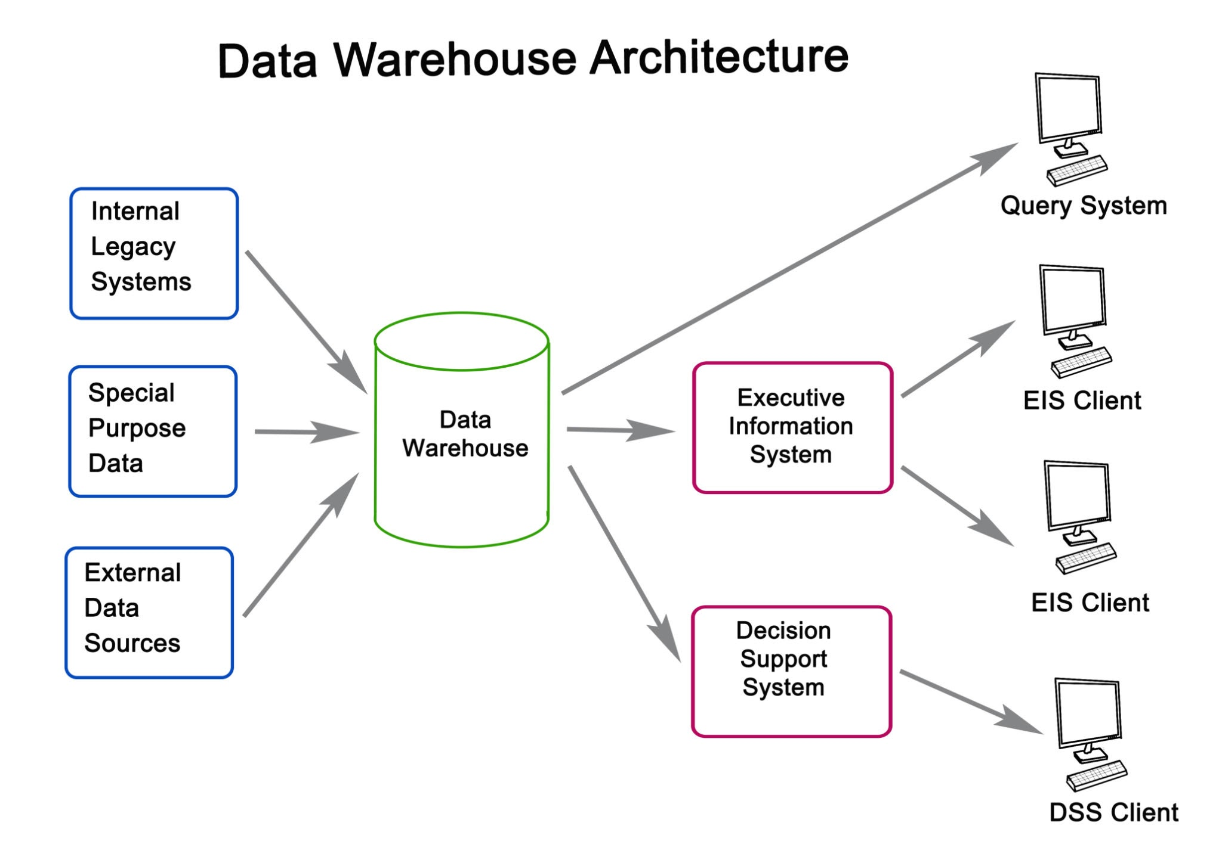
Getty Images
Code snippet
graph TD
subgraph Input_Layer [Inputs]
A[Excel/CSV] --> B{Agent Gateway}
C[APIs] --> B
D[BRD/Specs] --> E[Vector Embedding]
end

subgraph Logic_Layer [Agentic Brain]
E --> F[(Pinecone/Weaviate)]
F --> G[Architect Agent]
H[(Code Templates)] --> G
G --> I[ETL Generator]
end

subgraph Processing [Execution]
I --> J[Polars Transformation]
J --> K[Automated Unit Tests]
K --> L[Cleaned Data]
end

subgraph Output_Layer [Dashboard]
L --> M[Dash/Plotly UI]
M --> N[Business Logic Tooltips]
M --> O[Validation Report]
M --> P[Excel Export]
end

